📘 HUZLY SHIFT LOCCUM — Functional Specification Document (FSD)
Version 4.0 — Developer-Friendly Edition
Phase 1 — Pure Marketplace (Healthcare + Non-Healthcare)

1. Product Vision

What this means:
This section explains the ultimate purpose of the product so developers understand the “why” behind the system.
“To create a world where every shift is instantly filled, every worker is paid fairly and on time, and employers never suffer staffing shortages again.”
Huzly’s vision is to replace traditional staffing agencies with an on-demand shift marketplace similar to Uber, but for work shifts.

2. Mission Statement

What this means:
This is the guiding principle for all features and decisions.
“Huzly instantly connects verified workers with employers who need them — protected by upfront escrow, GPS-verified attendance, and AI-assisted dispute resolution.”
So every feature — escrow, ratings, disputes, messaging — exists to build trust between workers and employers.

3. Core Value Proposition

What this means:
Why will workers and employers use Huzly instead of agencies or other apps?

Workers
- Get shifts instantly
- Guaranteed weekly payout
- Protected by escrow
- Work across multiple industries
- Ratings boost their visibility

Employers
- Guaranteed coverage (escrow ensures commitment)
- Immediate access to vetted workers
- Lower cost than agencies
- AI helps resolve disputes fast
- Rating system ensures accountability
Understanding this helps devs prioritize performance and trust features.

4. Business Model (How Huzly Makes Money)

What this means:
Developers should understand revenue flows so they implement Stripe correctly.
- 15% platform fee on every shift
- Background check markup
- Future premium tier ($49/mo)
- Future 1099 automation tools
This means ANY shift transaction must correctly calculate:
- worker pay
- platform fee
- escrow
- payout
- stripe transfer

5. Tech Stack (Why These Tools?)

What this means:
Each chosen technology supports a core part of the system.
Layer | Reason
Bubble.io | rapid MVP development, fast UI iteration
BDK Native | easy app store publishing
Supabase PostgreSQL | scalable relational DB for Phase 2+
Supabase Storage | encrypted credential uploads
Stripe Connect | escrow + payouts + marketplace compliance
Mapbox | highly accurate GPS boundary detection
Grok API | AI dispute summaries
Checkr | instant background checks
Developers should understand how these integrate with Bubble.

6. Key Personas (Who We’re Building For)

What this means:
Personas help developers understand why certain UI layouts and flows differ.

Worker (Mobile)
- Uses the app like Uber/Doordash
- Wants immediate shifts
- Works across sectors
- Needs smooth GPS + simple screens

Employer (Desktop)
- Uses browser at work
- Posts shifts quickly
- Checks who claimed
- Handles disputes

Admin (Internal)
- Manages disputes, approvals, workers
- Tracks health of the system
Understanding personas ensures UI logic is implemented correctly.

7. Phase 1 Scope (What is INCLUDED vs EXCLUDED)

What this means:
Developers must understand MVP boundaries to avoid building extra features.

Included
Core 6 flows:
- Employer posts shift + escrow
- Worker claims shift
- GPS check-in/out
- Weekly payout
- Mandatory rating
- Dispute flow + AI
- Messaging
- Profiles

Excluded (Phase 2+)
- Full employee scheduling
- Requesting time off
- Availability calendars
- Team management
- Payroll processing
- Multi-day shifts
This ensures focus on launching quickly.

8. Detailed Functional Requirements

What this means:
This is the MOST IMPORTANT section for developers — it tells them exactly how the app should work, step by step.

⭐ 8.1 Worker (Mobile) – Functional Description

1. Sign-Up / Login
- Worker signs in with phone or email
- Must pass OTP verification
- Creates entries in user & worker tables
- Worker role determines which shifts they see

2. Onboarding Flow
Purpose → To match workers with the right shifts.
Worker enters:
- profile information
- job role (CNA, picker, etc.)
- work radius (distance willing to travel)
- uploads required credentials (CNA license, etc.)

3. Shift Feed
This screen acts like the “Uber map” but in list form.
Features:
- shows healthcare & non-healthcare shifts
- real-time search from the DB
- filters by pay, distance, date
- “Funds Locked” badge if employer prepaid escrow
- uses worker’s GPS (mobile only)

4. Shift Details
Worker sees:
- shift date/time
- pay rate
- facility location
- employer rating
- sector
- requirements
- "Funds Locked" badge ensures worker they WILL be paid

5. Claim Shift
Validation logic:
- No overlapping shifts
- Worker role matches shift role
- Can’t claim if escrow not paid
- Sets shift.status = “Claimed”

6. GPS Check-In/Out
On shift start:
- Worker must be inside geo-fence radius (e.g., 150m)
- Logs timestamp + gps coordinates → gps_log table
- Timer shows active hours
On shift end:
- Check-out updates shift hours worked

7. Weekly Earnings Dashboard
Worker sees:
- “Pending escrow” → once employer posts shift
- “Available for payout next Friday” → once shift completed
- “Released” → once Stripe transfer is done

8. Mandatory Rating
Worker MUST rate employer to unlock payout for that week.

9. Messaging
Each shift has its own chat thread.
Stored in message table, real-time via Supabase subscriptions.

10. Profile
Shows:
- credentials
- skills
- rating score
- history of completed shifts

⭐ 8.2 Employer (Desktop) – Functional Description

1. Employer Onboarding
Employer enters:
- facility name
- address
- contact details
- adds payment method (Stripe linking)

2. Employer Dashboard
Shows:
- open shifts
- shifts claimed
- shifts disputed
- weekly payroll-like summary

3. Post a Shift (Important)
Employer enters:
- role needed
- pay rate
- date/time
- sector toggle (healthcare / non)
- credentials required
System calculates:
- total escrow = estimated hours × pay rate
- employer must pay escrow to post shift

4. Shift Management
Employer sees all posted shifts:
- who claimed
- shift status (posted, claimed, active, completed)
- can cancel before worker claims
- can dispute after completion

5. Mandatory Worker Rating
Employer must submit rating after the week ends.
No rating = payout blocked.

6. Disputes
Employer can dispute:
- no-show
- incomplete work
- lateness
- incorrect hours
Flow:
- Employer opens dispute
- Uploads proof
- Grok generates AI summary
- Admin makes final decision
- Payment is held until dispute resolved

7. Billing & Escrow History
Shows all escrow charges:
- shift-by-shift
- weekly statements
- Stripe receipts

⭐ 8.3 Admin – Functional Description

1. Admin Dashboard
Shows:
- total active employers
- active workers
- total shifts
- escalated disputes
- live system alerts

2. Admin User Management
Admin can:
- approve new workers
- reject fake/incorrect credentials
- suspend users
- approve new employers/facilities

3. Dispute Resolution Panel
Shows:
- worker GPS logs
- employer uploads
- AI verdict
- history of both users
Admin selects:
- “Approve worker” → payout proceeds
- “Approve employer” → refund escrow

4. Logs
System logs stored in:
- webhook_log
- error_log
- ai_review_log
- activity_log
Used for debugging issues.

9. Data Model – Developer Explanation

What this means:
The data model is the core of the system.
Developers must understand relationships.
Below are the key tables from your PostgreSQL schema
(confirmed via upload).

🔑 Core Entities
Table | Description
user | Login, roles, status
worker | Worker-specific info
employer | Employer account (user-level)
facility | Each work location
shift | Every posted shift
shift_claim | (if used as linking table)
payout | Weekly payments
dispute | Employer opens disputes
rating | Ratings both sides
gps_log | GPS-tracked check-in/out
message | Chat messages per shift
notification | Alerts
credential | Worker uploaded credentials
webhook_log | Stripe and Mapbox webhooks
error_log | Error tracking
system_config | Platform-wide rules
These are mapped directly to your SQL script (29 tables).

10. Timeline – Developer Explanation

What this means:
Developers know the expected order of completion.
Week 1–2 → UX + Bubble foundation
Week 3–5 → Core build (shift, GPS, payouts, claims)
Week 6 → QA, bug-fix, launch

11. Pilot Success Metrics – Why They Matter for Developers
Developers must understand what counts as “done.”

Technical KPIs
- < 2% GPS check-in errors
- < 1% failed payouts
- < 1 sec load time for shift feed

Business KPIs
- 10 facilities using system
- 200 shifts filled
- <5% disputes
- App rating ≥ 4.7
This helps devs focus on performance.

12. Risks & Mitigations (Dev-Centric)

Bubble Performance
→ Use SQL-backed search + indexed fields.

Dispute Abuse
→ AI summary + admin verification.

Poor Adoption
→ Ensure UX is smooth, fast, mobile-first.
📘 A PRD (Product Requirements Document)
📊 A System Architecture Diagram
📱 Screen-by-screen flow diagram
📄 Executive Summary
🧩 Task Breakdown by Week and Developer
📦 A combined Notion workspace template

A System Architecture Diagram

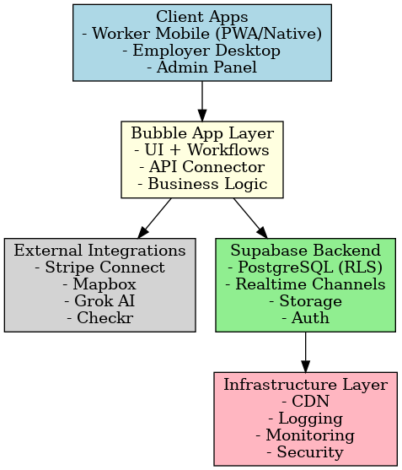

This below diagram shows:
- Employers → posting shifts / seeing claims
- Workers → browsing & claiming shifts
- Huzly Core Shift Engine → posting, matching, claiming
- Escrow & Payments (Stripe Connect) → charges + holds
- Payout Engine → weekly, rating-gated payouts to workers
- Dispute & AI Review (Grok + Admin) → freeze/release funds
- Data & Analytics (Supabase) → shifts, transactions, disputes, logs

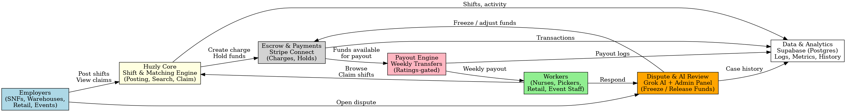

Worker Flows

This diagram shows the complete end-to-end worker journey:
- Login / OTP
- Onboarding
  - Profile
  - Roles
  - Credentials
  - Radius
- Shift Feed
- Shift Details
- Claim Shift
- Active Shift
  - GPS Check-In / Check-Out
  - Mapbox timer
  - Geo-fence
- In-Shift Messaging
- Weekly Earnings Dashboard
- Mandatory Employer Rating
- Payout Released (Stripe Connect)

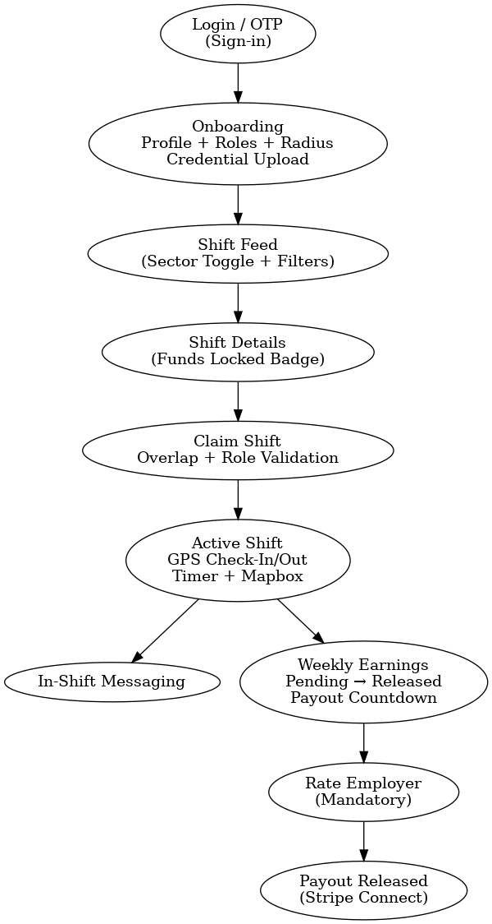

EMPLOYER WORKFLOWS
This flow shows the full employer journey:
- Employer Login / Sign-Up
- Facility Onboarding – business info, locations, payment method
- Employer Dashboard – open/filled/disputed shifts, “Post Shift” CTA
- Post Shift Form – role, sector, time, pay, credentials
- Escrow Payment (Stripe) – confirm & pay, funds locked
- Shift Live – visible in worker feed
- Shift Management – see who claimed, status, details
- Rate Worker (Mandatory) – required to release payout
- Dispute Flow (Optional) – proof upload, AI verdict preview
- Billing & Escrow History – invoices, receipts, adjusted payouts
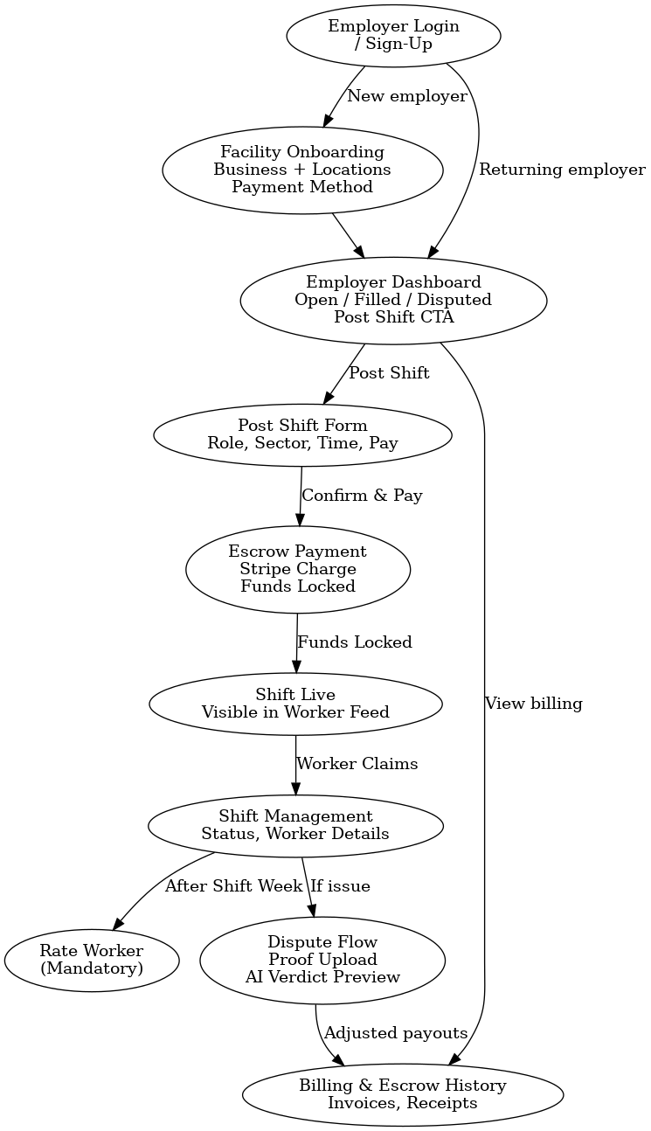
Combined Worker Employer Workflow

What this diagram shows
Worker Journey (left):
- Login / OTP
- Onboarding (profile, roles, radius, credentials)
- Shift Feed (sector toggle + filters)
- Shift Details (Funds Locked badge)
- Claim Shift (overlap & role validation)
- Active Shift (GPS check-in/out, map, timer)
- In-Shift Chat
- Weekly Earnings (pending → released)
- Rate Employer (mandatory)
Employer Journey (right):
- Login / Sign-Up
- Facility Onboarding (business, locations, payment)
- Dashboard (open/filled/disputed)
- Post Shift (role, sector, pay, time)
- Escrow Payment (Stripe, funds locked)
- Shift Live (visible to workers)
- Manage Shifts (assigned worker, status)
- Rate Worker (mandatory)
- Dispute Flow (proof upload + AI preview)
- Billing & Escrow History
Shared System Components (center):
- Huzly Core / Shift Engine → shift creation, status, matching
- Escrow & Payments (Stripe Connect) → hold funds after shift posting
- Payout Engine → weekly, rating-gated worker payouts
- Dispute Engine (Grok AI + Admin) → freezes/adjusts funds when disputes happen

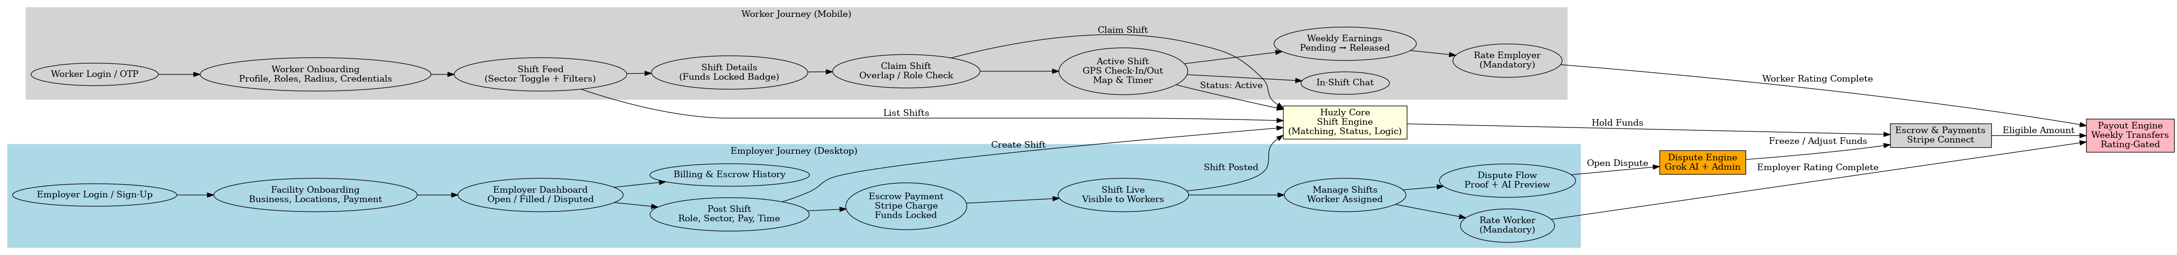

Complete End to end Worker- Employer- Admin workflow

Worker Journey (Mobile)
- Login / OTP
- Onboarding (profile, roles, radius, credentials)
- Shift feed → shift details → claim
- Active shift (GPS, map, timer)
- In-shift chat
- Weekly earnings
- Mandatory rating → payout released

Employer Journey (Desktop)
- Login / sign-up
- Facility onboarding
- Dashboard → post shift
- Escrow payment (Funds Locked)
- Shift goes live & workers can claim
- Manage shift (view worker details)
- Rate worker (mandatory)
- Dispute flow (proof upload + AI preview)
- Billing & escrow history

Admin Journey (Internal)
- Login
- Admin dashboard (metrics, alerts)
- User management
- Dispute panel (GPS logs, AI verdict)
- Final decision → freeze/release funds

System Components
- Huzly Core (Shift Engine)
- Escrow Engine (Stripe Connect)
- Payout Engine (rating-gated weekly payout)
- Dispute Engine (Grok AI + admin rules)
- Supabase Backend (PostgreSQL + RLS + Realtime)

